Octagon
# Source: AI Source: Provided by: [Data Path: Persons Table -> ID Column: 1, Name_En Column: Motasem Essam] -> From: [ChatGPT] on [7/25/2026]
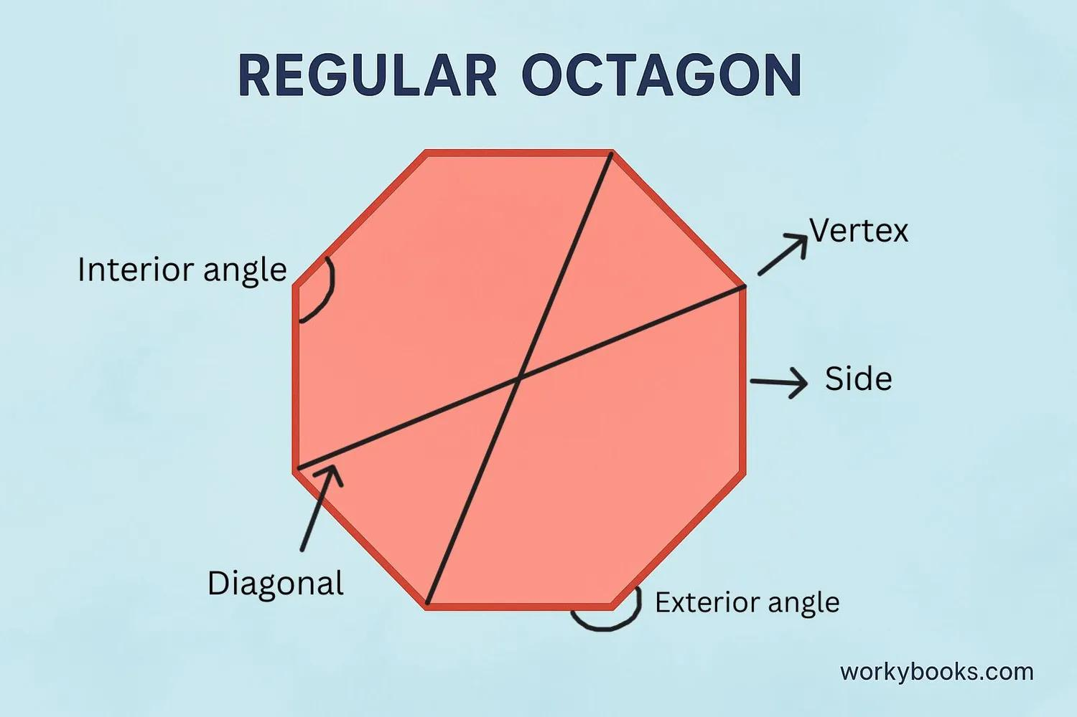
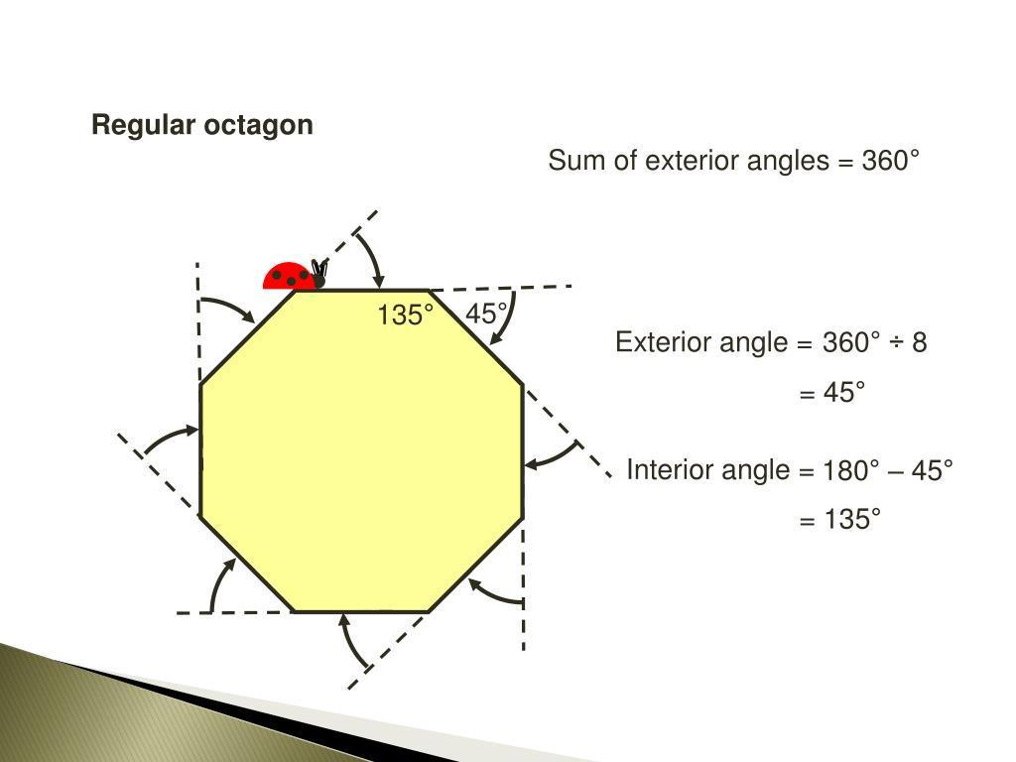
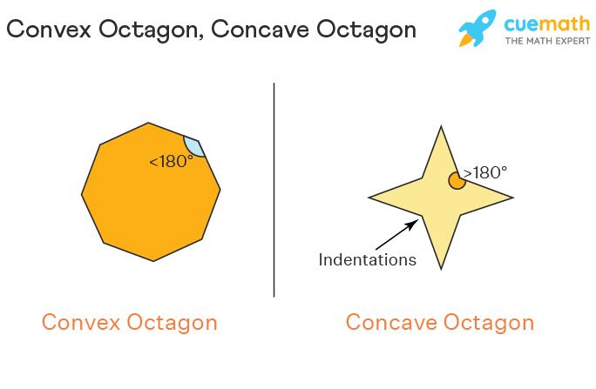
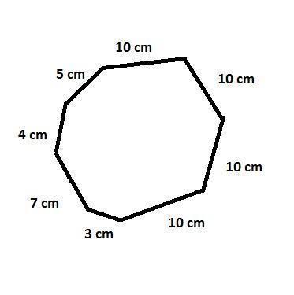
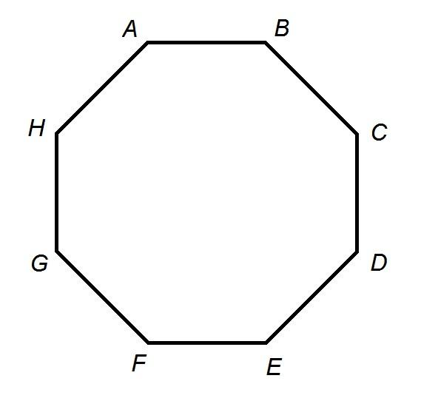
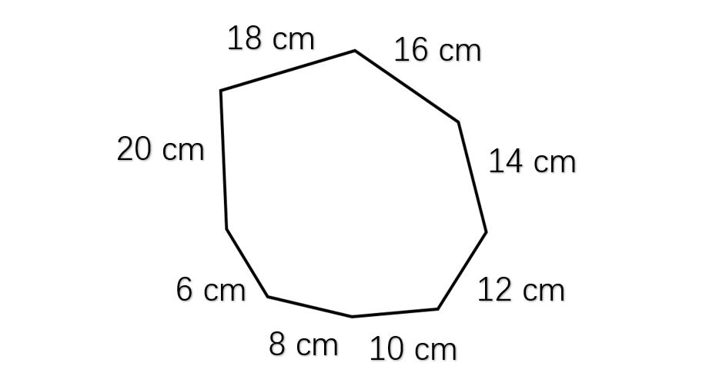

Definition
# Source: AI Source: Provided by: [Data Path: Persons Table -> ID Column: 1, Name_En Column: Motasem Essam] -> From: [ChatGPT] on [7/25/2026]
An octagon is a polygon with eight straight sides.
Therefore, an octagon has:
- 8 sides
- 8 vertices
- 8 interior angles
- 8 exterior angles
- 20 diagonals
A general octagon can be convex or concave, regular or irregular, and symmetric or asymmetric.

Fundamental Elements
# Source: AI Source: Provided by: [Data Path: Persons Table -> ID Column: 1, Name_En Column: Motasem Essam] -> From: [ChatGPT] on [7/25/2026]
Consider an octagon $ABCDEFGH$:
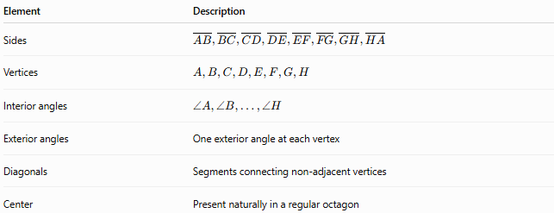
Element | Description
Sides | $$\overset{‾}{AB},\overset{‾}{BC},\overset{‾}{CD},\overset{‾}{DE},\overset{‾}{EF},\overset{‾}{FG},\overset{‾}{GH},\overset{‾}{HA}$$
Vertices | $$A,B,C,D,E,F,G,H$$
Interior angles | $$∠A,∠B,…,∠H$$
Exterior angles | One exterior angle at each vertex
Diagonals | Segments connecting non-adjacent vertices
Center | Present naturally in a regular octagon

Classification of Octagons
# Source: AI Source: Provided by: [Data Path: Persons Table -> ID Column: 1, Name_En Column: Motasem Essam] -> From: [ChatGPT] on [7/25/2026]
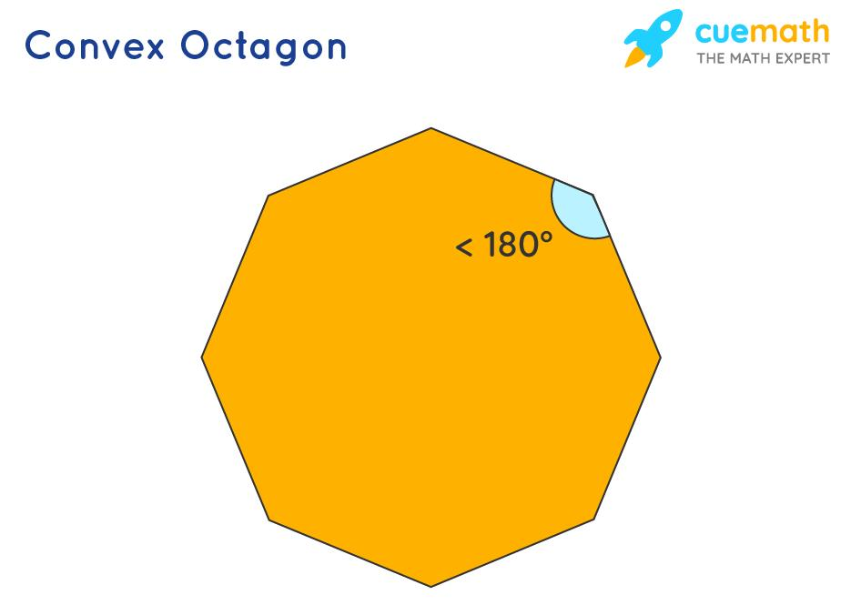
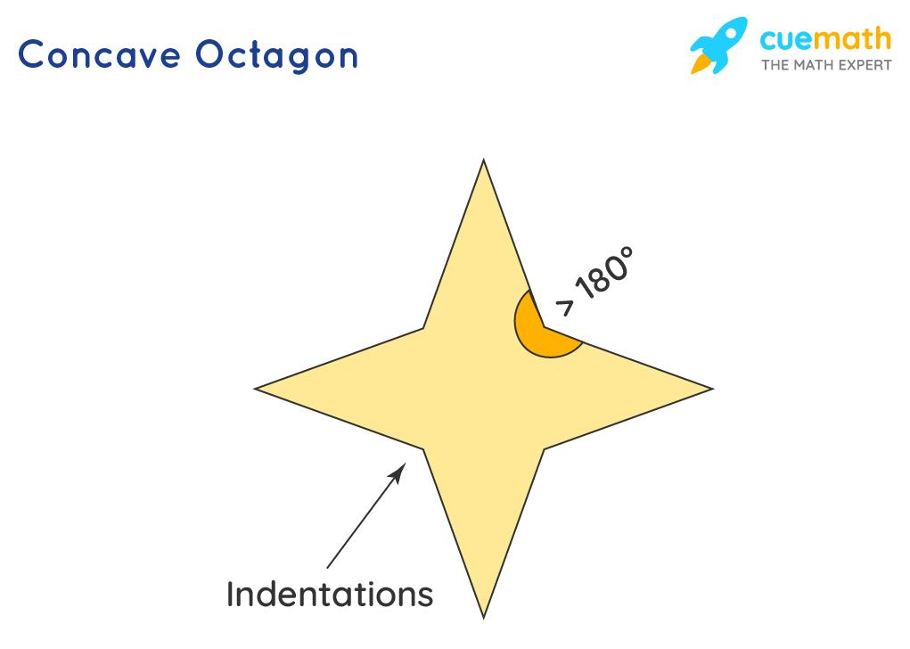
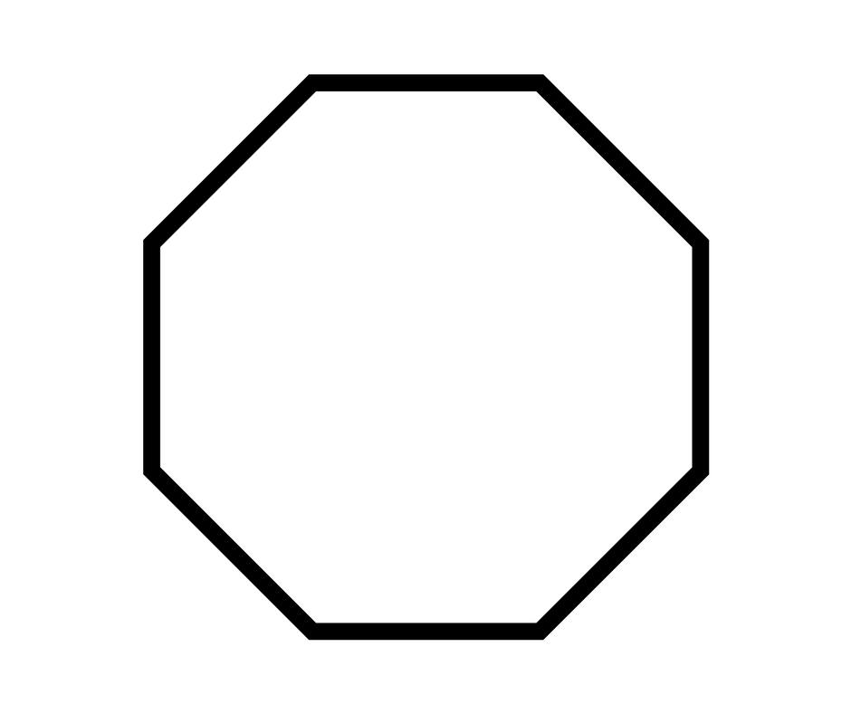
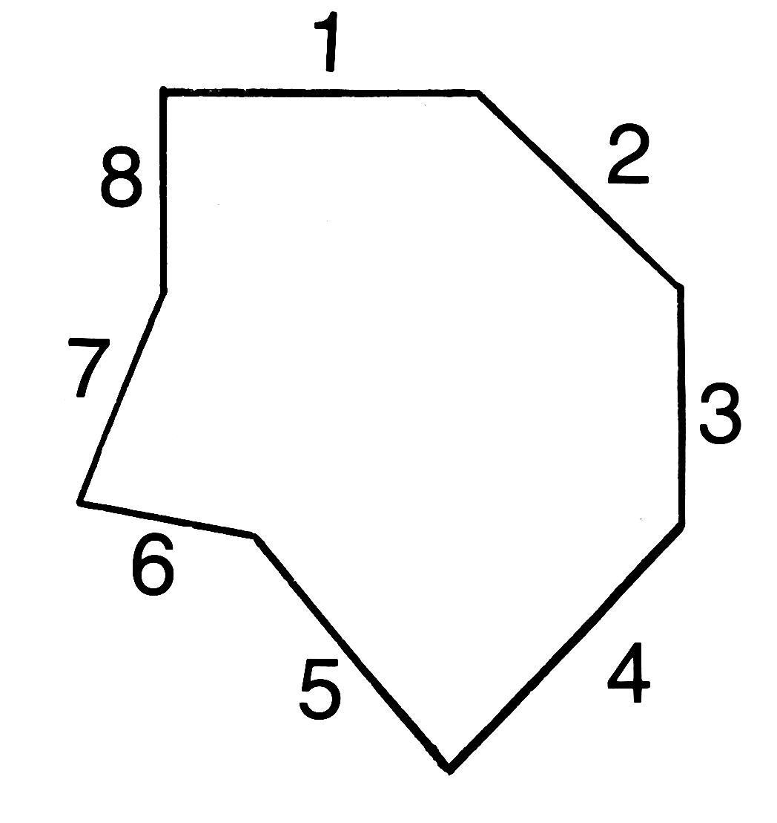
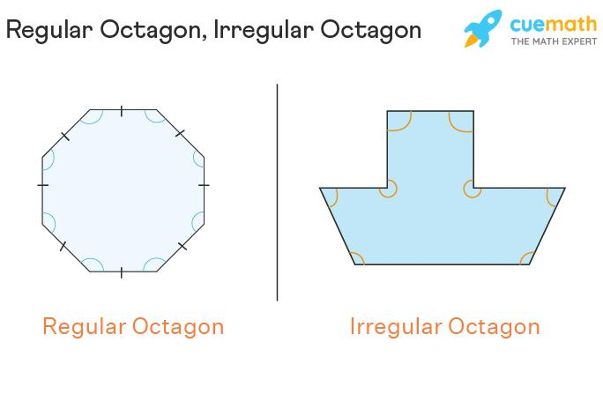
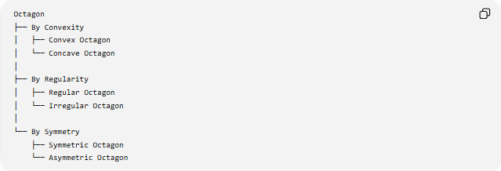
Octagon
├── By Convexity
│ ├── Convex Octagon
│ └── Concave Octagon
│
├── By Regularity
│ ├── Regular Octagon
│ └── Irregular Octagon
│
└── By Symmetry
├── Symmetric Octagon
└── Asymmetric Octagon

Convex Octagon
# Source: AI Source: Provided by: [Data Path: Persons Table -> ID Column: 1, Name_En Column: Motasem Essam] -> From: [ChatGPT] on [7/25/2026]
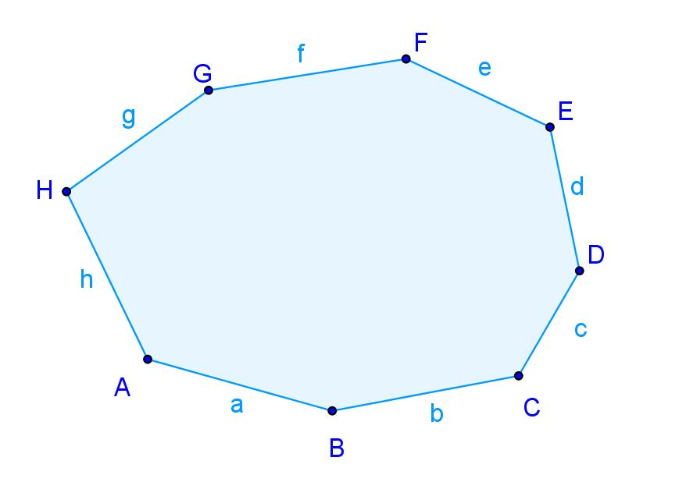
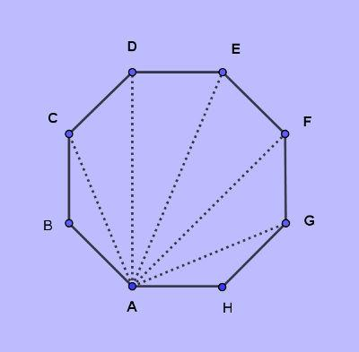
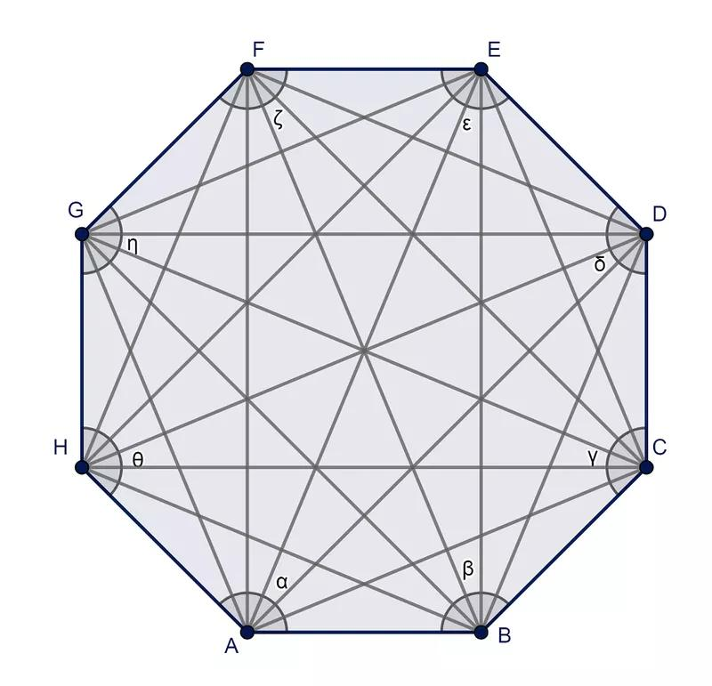
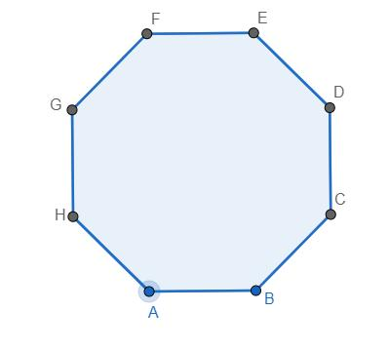
A convex octagon is an octagon in which every interior angle is less than ${180}^{∘}$.
Properties
- All 8 interior angles are $<{180}^{∘}$.
- There are no inward indentations.
- Every diagonal lies completely inside the octagon.
- Any line segment connecting two points of the octagon remains inside it.
Example
A regular octagon is always convex.

Concave Octagon
# Source: AI Source: Provided by: [Data Path: Persons Table -> ID Column: 1, Name_En Column: Motasem Essam] -> From: [ChatGPT] on [7/25/2026]
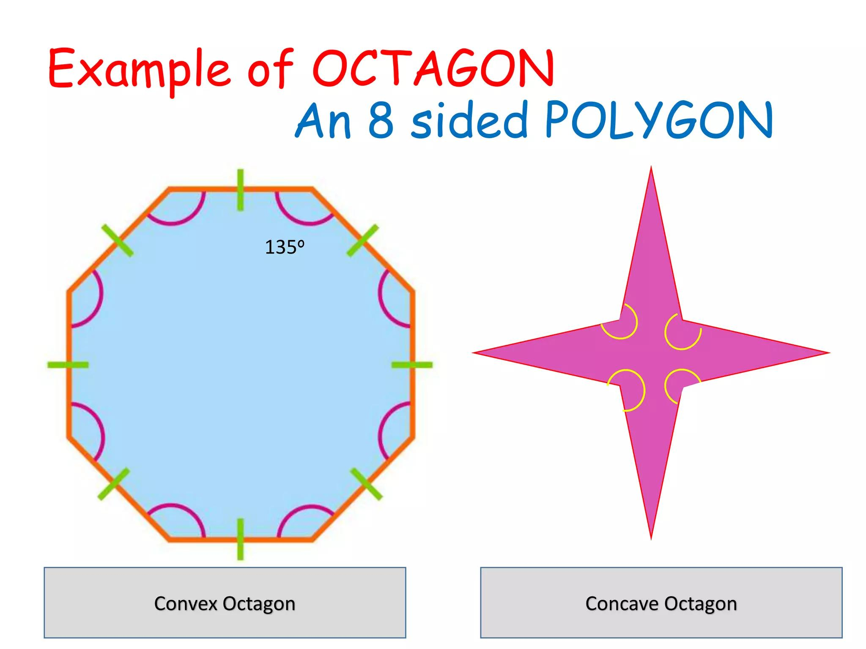
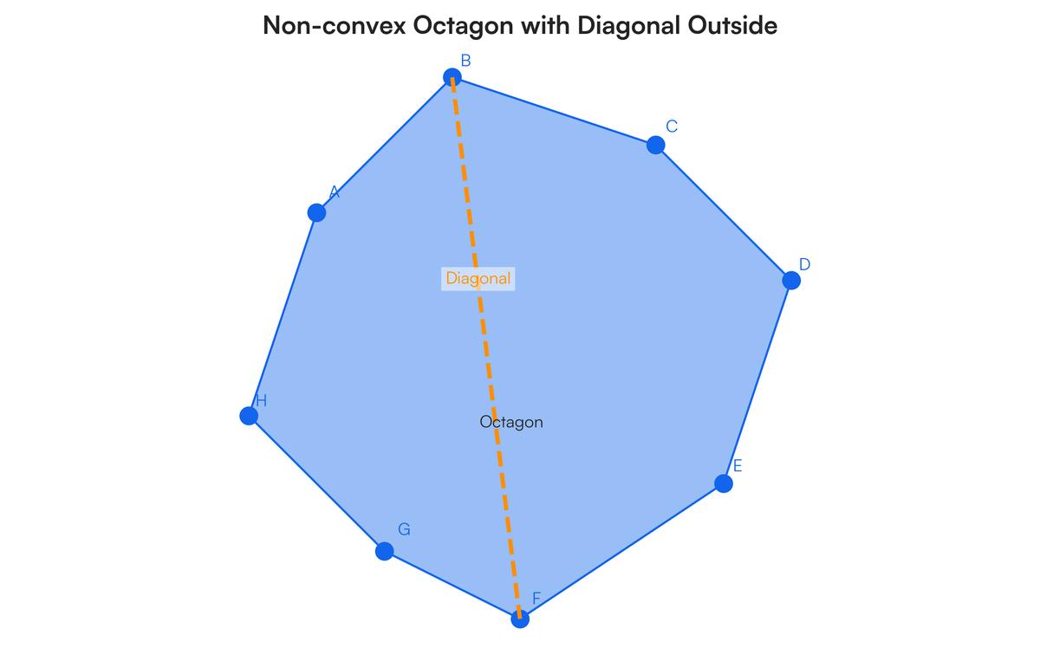
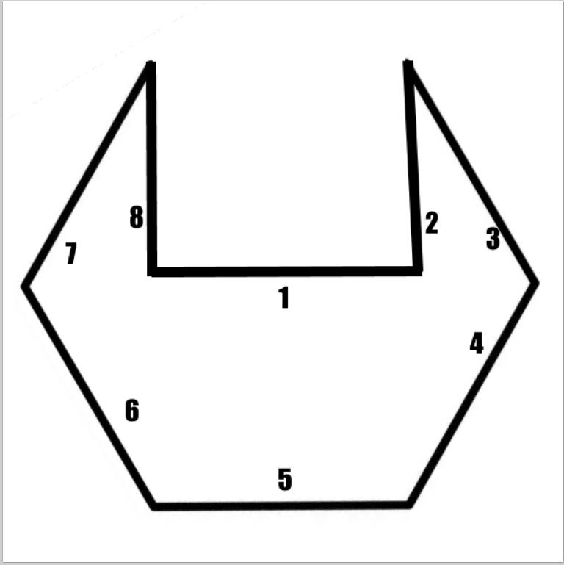
A concave octagon is an octagon with at least one interior angle greater than ${180}^{∘}$.
Properties
- At least one interior angle is $>{180}^{∘}$.
- It has at least one inward indentation.
- At least one diagonal can lie partly outside the octagon.
- It is not convex.

Regular Octagon
# Source: AI Source: Provided by: [Data Path: Persons Table -> ID Column: 1, Name_En Column: Motasem Essam] -> From: [ChatGPT] on [7/25/2026]
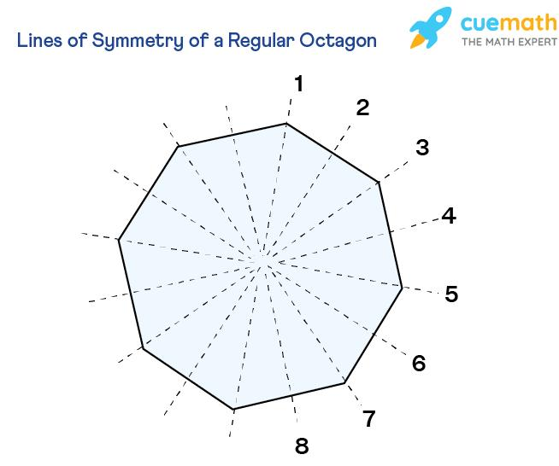
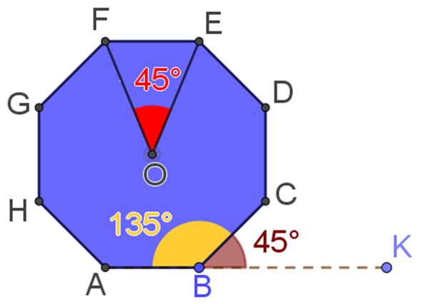
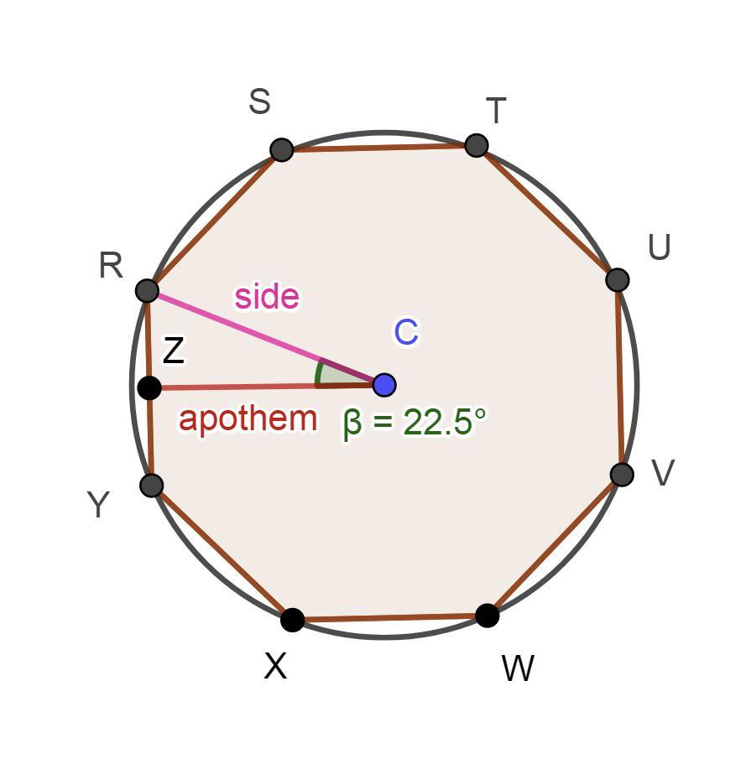
A regular octagon is an octagon with:
- 8 equal sides
- 8 equal interior angles
Interior Angle
The sum of the interior angles is:
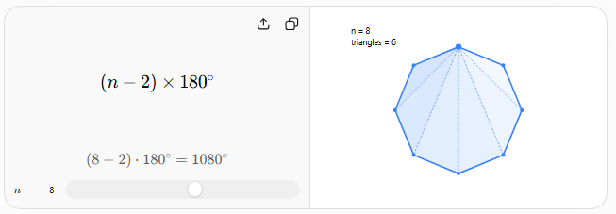
$$\left(8-2\right)×{180}^{∘}={1080}^{∘}$$
Therefore, each interior angle is:
$$\frac{{1080}^{∘}}{8}={135}^{∘}$$
Exterior Angle
$$\frac{{360}^{∘}}{8}={45}^{∘}$$
Central Angle
For a regular octagon:
$$\frac{{360}^{∘}}{8}={45}^{∘}$$
Perimeter
If each side has length $a$:
$$\boxed{P=8a}$$
Area
For side length $a$:
$$\boxed{A=2\left(1+\sqrt{2}\right)a^{2}}$$
Symmetry
A regular octagon has:
- 8 lines of symmetry
- Rotational symmetry of order 8
- Smallest rotational angle: ${45}^{∘}$

Irregular Octagon
# Source: AI Source: Provided by: [Data Path: Persons Table -> ID Column: 1, Name_En Column: Motasem Essam] -> From: [ChatGPT] on [7/25/2026]
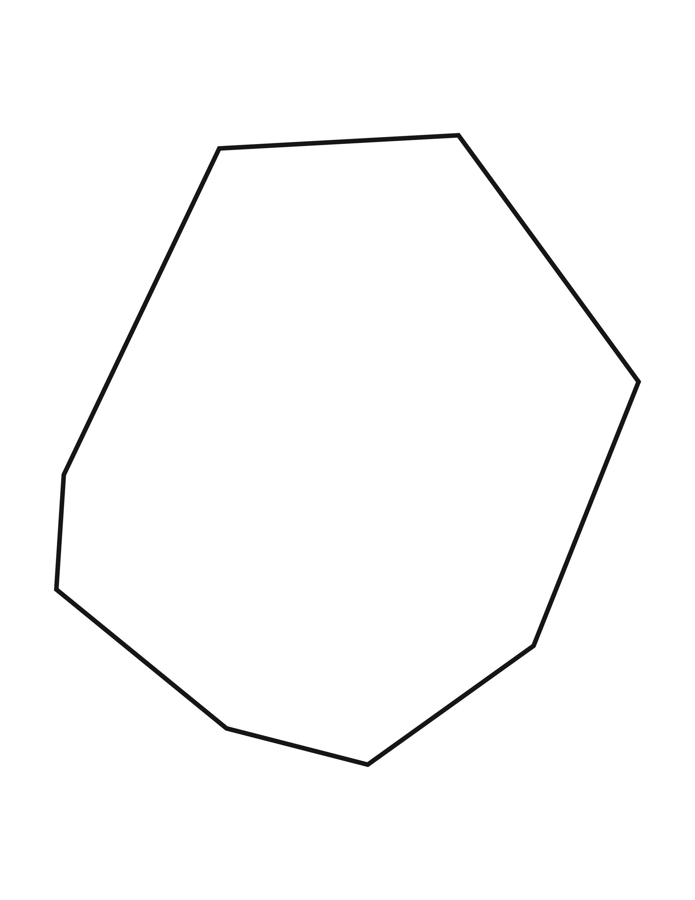
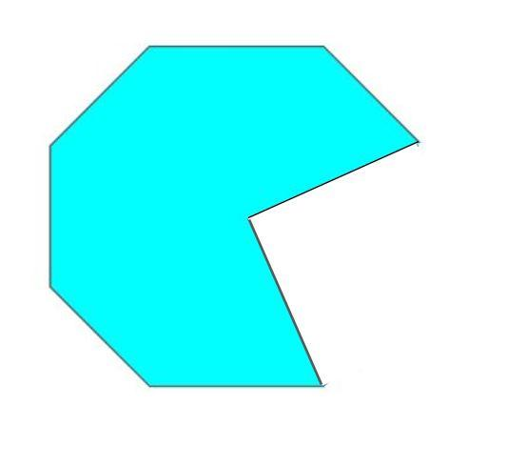
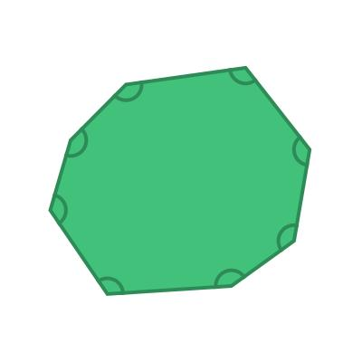
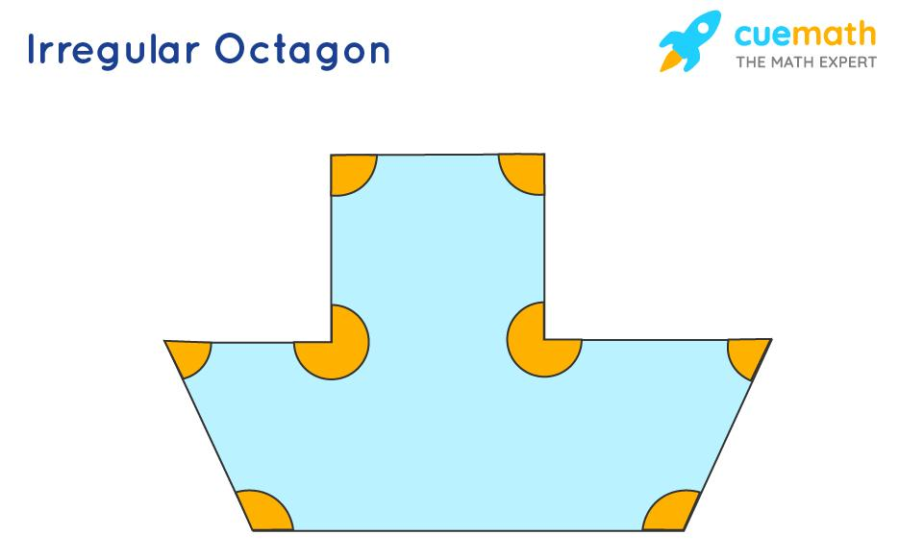
An irregular octagon is an octagon that does not have all eight sides and all eight angles equal.
It may have:
- Different side lengths
- Different angle measures
- Some equal sides
- Some equal angles
- Reflection symmetry
- Rotational symmetry
- No symmetry
An irregular octagon may also be either convex or concave.

Symmetric Octagon
# Source: AI Source: Provided by: [Data Path: Persons Table -> ID Column: 1, Name_En Column: Motasem Essam] -> From: [ChatGPT] on [7/25/2026]
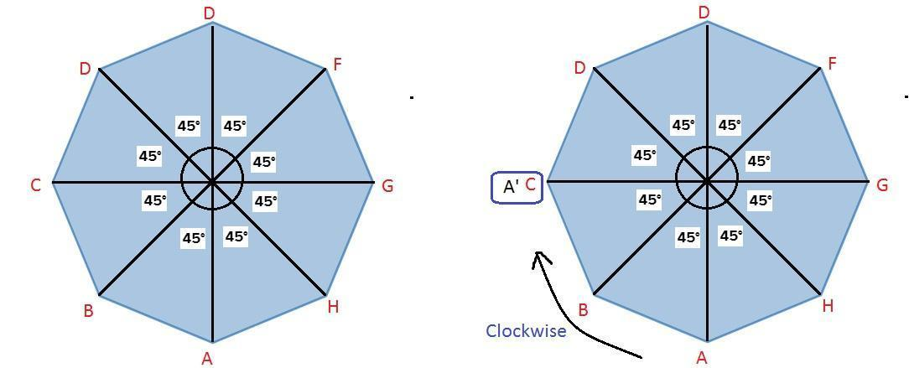
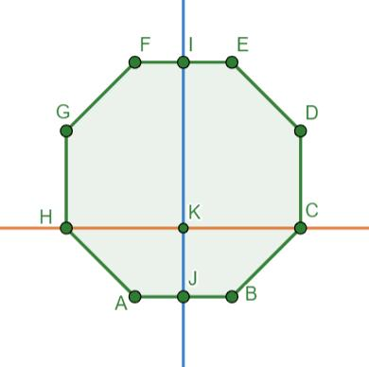
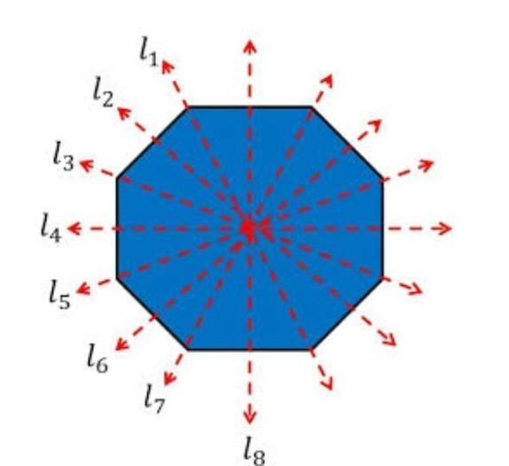
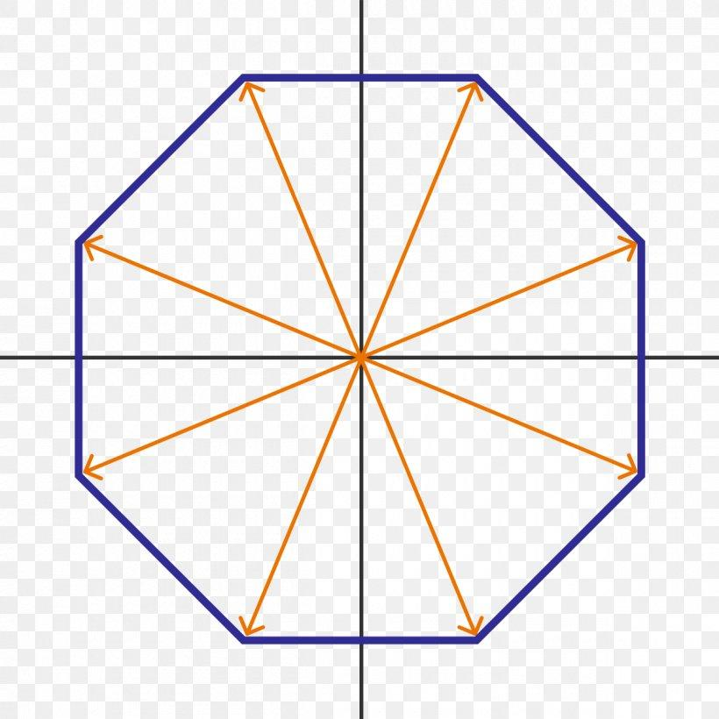
A symmetric octagon has at least one nontrivial symmetry.
It may have:
- Reflection symmetry
- Rotational symmetry
- Or both
A regular octagon has particularly strong symmetry, with 8 lines of reflection symmetry and rotational symmetry of order 8.

Asymmetric Octagon
# Source: AI Source: Provided by: [Data Path: Persons Table -> ID Column: 1, Name_En Column: Motasem Essam] -> From: [ChatGPT] on [7/25/2026]
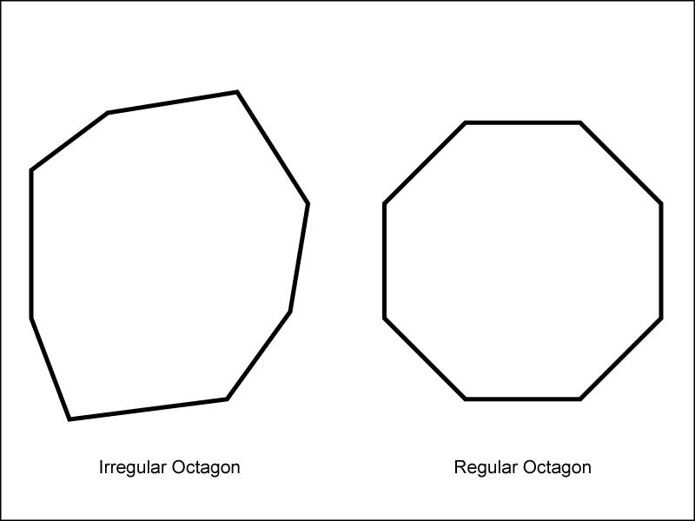

An asymmetric octagon has:
- No line of reflection symmetry
- No nontrivial rotational symmetry
It can still be either convex or concave.

Interior Angle Sum
# Source: AI Source: Provided by: [Data Path: Persons Table -> ID Column: 1, Name_En Column: Motasem Essam] -> From: [ChatGPT] on [7/25/2026]
For any octagon:
$$\boxed{S=\left(8-2\right)×{180}^{∘}} \\ \boxed{S={1080}^{∘}}$$
Thus, the sum of the eight interior angles is always ${1080}^{∘}$.
For a regular octagon:
$$\boxed{\text{Each interior angle}={135}^{∘}}$$

Number of Diagonals
# Source: AI Source: Provided by: [Data Path: Persons Table -> ID Column: 1, Name_En Column: Motasem Essam] -> From: [ChatGPT] on [7/25/2026]
The number of diagonals of an $n$-sided polygon is:
$$D=\frac{n\left(n-3\right)}{2}$$
For an octagon:
$$D=\frac{8\left(8-3\right)}{2} \\ \boxed{D=20}$$
From each vertex, there are:
$$8-3=5$$
diagonals.

Triangulation
# Source: AI Source: Provided by: [Data Path: Persons Table -> ID Column: 1, Name_En Column: Motasem Essam] -> From: [ChatGPT] on [7/25/2026]
A convex octagon can be divided into:
$$n-2=8-2=6$$
triangles.
Therefore:
$$\boxed{\text{6 triangles}}$$
The total angle sum can consequently be obtained as:
$$6×{180}^{∘}={1080}^{∘}$$

Regular Octagon Measurements
# Source: AI Source: Provided by: [Data Path: Persons Table -> ID Column: 1, Name_En Column: Motasem Essam] -> From: [ChatGPT] on [7/25/2026]
For a regular octagon with side length $a$:
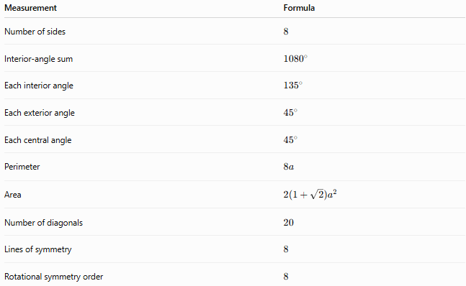
Measurement | Formula
Number of sides | $$8$$
Interior-angle sum | $${1080}^{∘}$$
Each interior angle | $${135}^{∘}$$
Each exterior angle | $${45}^{∘}$$
Each central angle | $${45}^{∘}$$
Perimeter | $$8a$$
Area | $$2\left(1+\sqrt{2}\right)a^{2}$$
Number of diagonals | $$20$$
Lines of symmetry | $$8$$
Rotational symmetry order | $$8$$

Example
# Source: AI Source: Provided by: [Data Path: Persons Table -> ID Column: 1, Name_En Column: Motasem Essam] -> From: [ChatGPT] on [7/25/2026]
Suppose a regular octagon has side length:
$$a=5$$
Perimeter
$$P=8a \\ P=8\left(5\right)=\boxed{40}$$
Area
$$A=2\left(1+\sqrt{2}\right)a^{2} \\ A=2\left(1+\sqrt{2}\right)\left(25\right) \\ \boxed{A=50\left(1+\sqrt{2}\right)}$$
Approximately:
$$\boxed{A≈120.71}$$

Real-World Examples
# Source: AI Source: Provided by: [Data Path: Persons Table -> ID Column: 1, Name_En Column: Motasem Essam] -> From: [ChatGPT] on [7/25/2026]



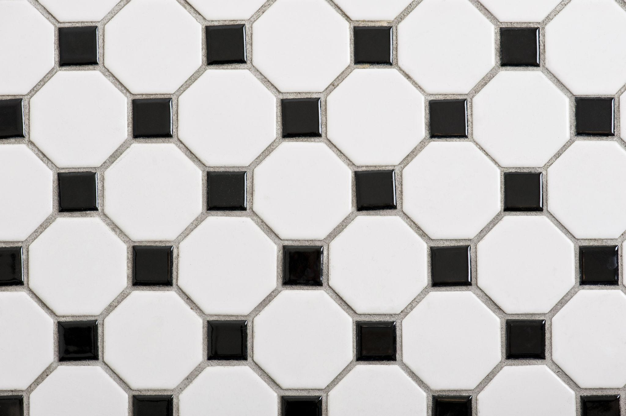


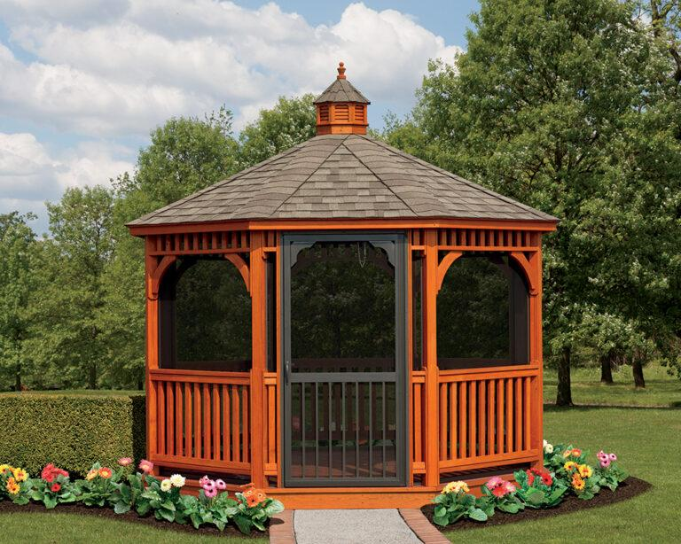
Octagonal shapes appear in:
- Stop signs
- Architectural structures
- Gazebos
- Towers
- Floors and tiles
- Decorative patterns
- Tables
- Mirrors
- Windows
- Sports and recreational structures

Relationship to Other Polygons
# Source: AI Source: Provided by: [Data Path: Persons Table -> ID Column: 1, Name_En Column: Motasem Essam] -> From: [ChatGPT] on [7/25/2026]
An octagon belongs to the family of polygons:
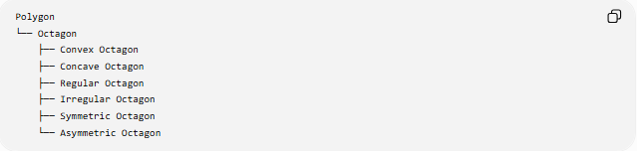
Polygon
└── Octagon
├── Convex Octagon
├── Concave Octagon
├── Regular Octagon
├── Irregular Octagon
├── Symmetric Octagon
└── Asymmetric Octagon
It follows the general polygon formulas:
$$\text{Interior-angle sum}=\left(n-2\right){180}^{∘} \\ \text{Diagonals}=\frac{n\left(n-3\right)}{2}$$
For $n=8$, these become ${1080}^{∘}$and $20$diagonals.

Key Points
# Source: AI Source: Provided by: [Data Path: Persons Table -> ID Column: 1, Name_En Column: Motasem Essam] -> From: [ChatGPT] on [7/25/2026]
- An octagon has 8 sides.
- It has 8 vertices and 8 interior angles.
- The interior-angle sum is ${1080}^{∘}$.
- A regular octagon has ${135}^{∘}$interior angles.
- Each exterior and central angle of a regular octagon is ${45}^{∘}$.
- An octagon has 20 diagonals.
- A convex octagon has no inward indentation.
- A concave octagon has at least one interior angle greater than ${180}^{∘}$.
- A regular octagon has 8 lines of symmetry and rotational symmetry of order 8.
- A convex octagon can be divided into 6 triangles.

Conclusion
# Source: AI Source: Provided by: [Data Path: Persons Table -> ID Column: 1, Name_En Column: Motasem Essam] -> From: [ChatGPT] on [7/25/2026]
An octagon is an eight-sided polygon that can be classified according to convexity, regularity, and symmetry. The regular octagon is especially important because of its equal sides, equal angles, strong symmetry, and simple formulas for perimeter and area.

